Email Investigation
Step 1 Check Email Headers
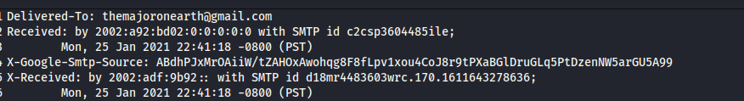

Step 2 Check For Authentication Protocol-> check that all three protocol are passed SRF,DKIM,DMARC

Step 3 File/Attachment Information
Decoding the base 64 pdf file to hex using cyberchef

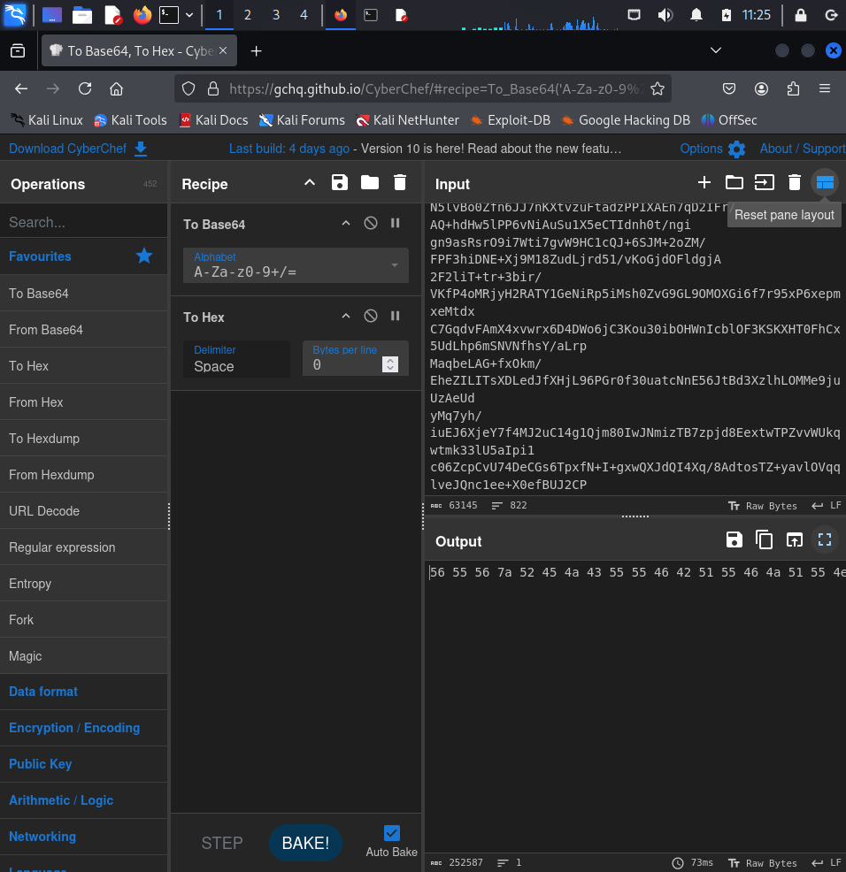

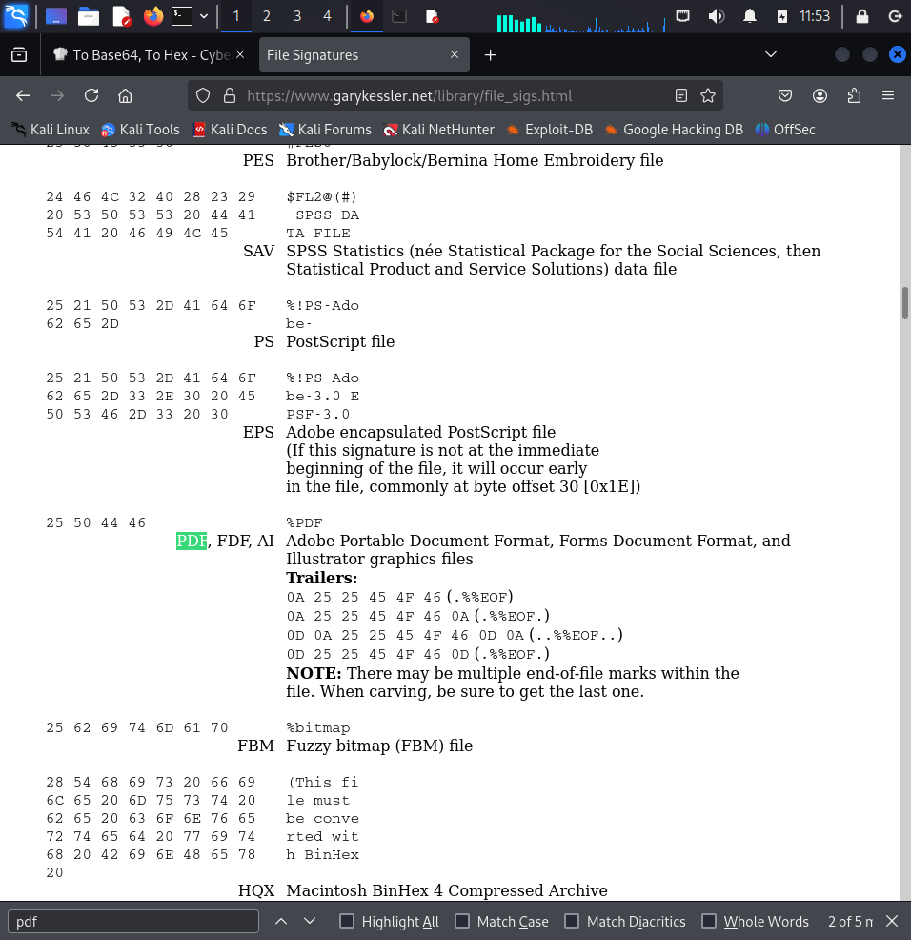

Both the Hex Value Doesn’t match

Now We Will Create a attach.zip file from the output of cyberchef and will extract it
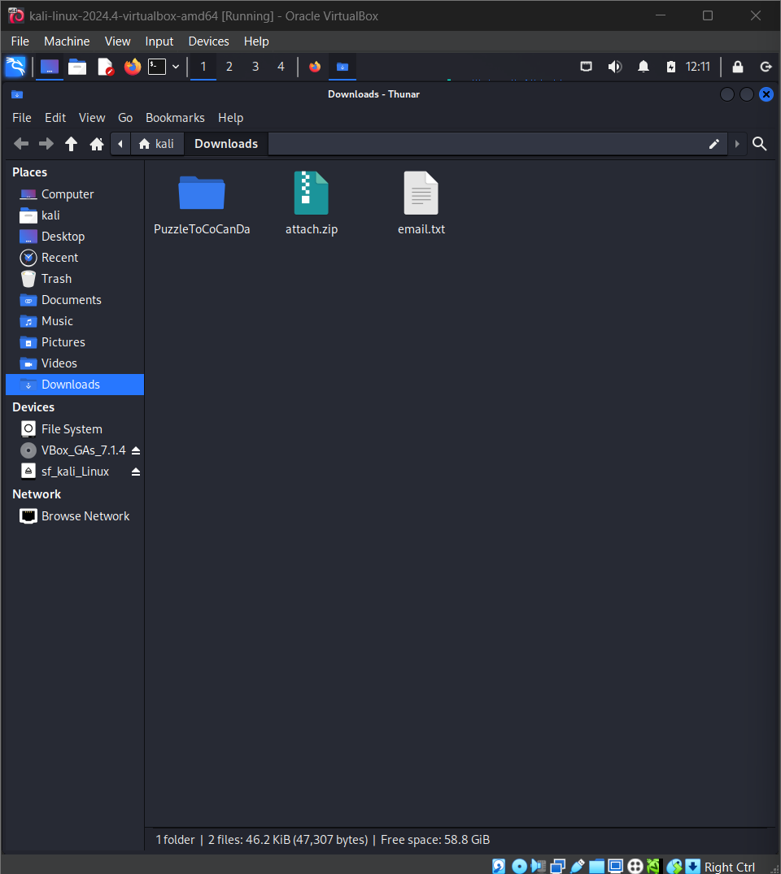

Verification of Zip file
Installing Ghex- sudo apt install ghex
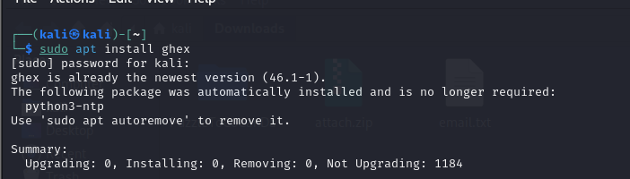

To Scan all metadata at once-exiftool -u PuzzleToCoCanDa/*
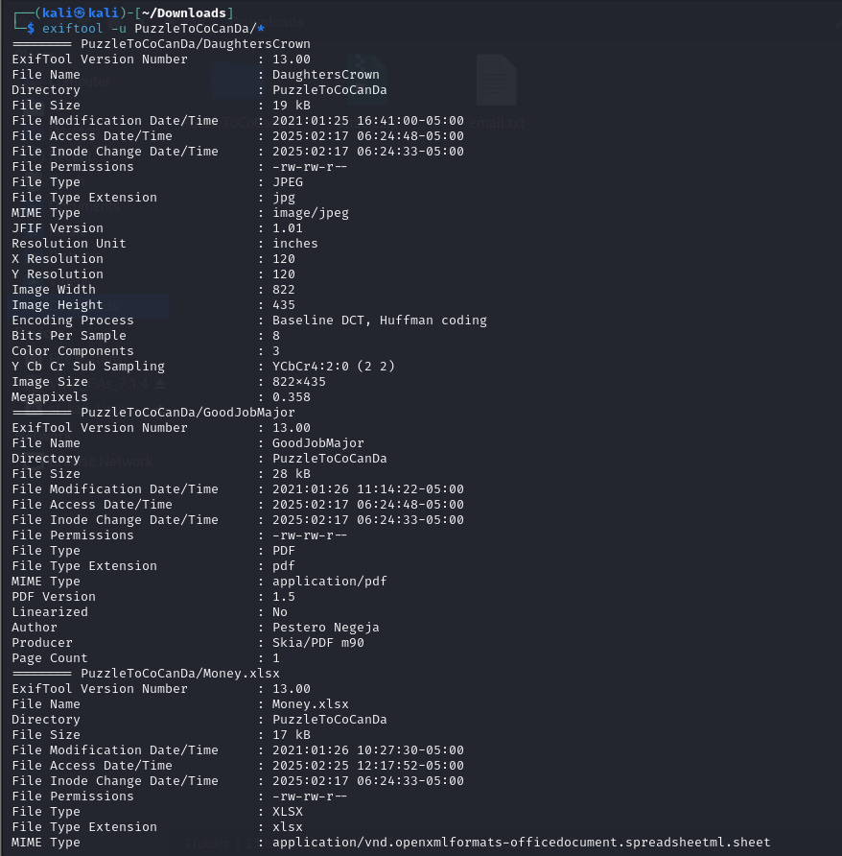
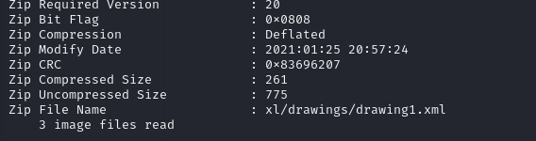

To Check the Hex values of document- ghex
- DaughtersCrown
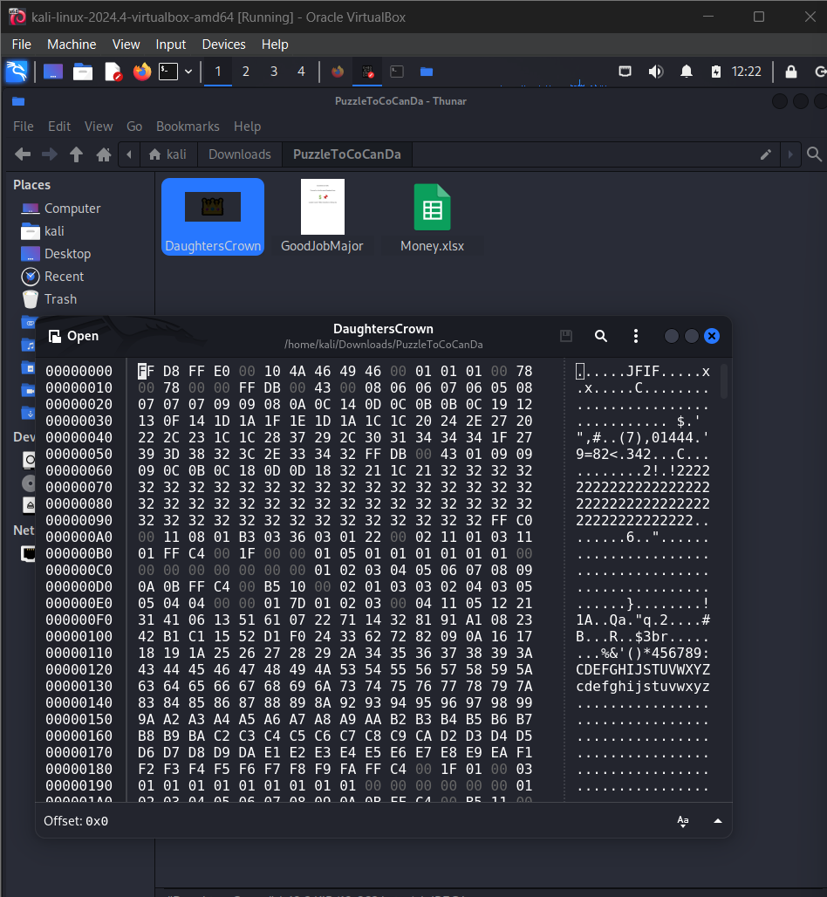
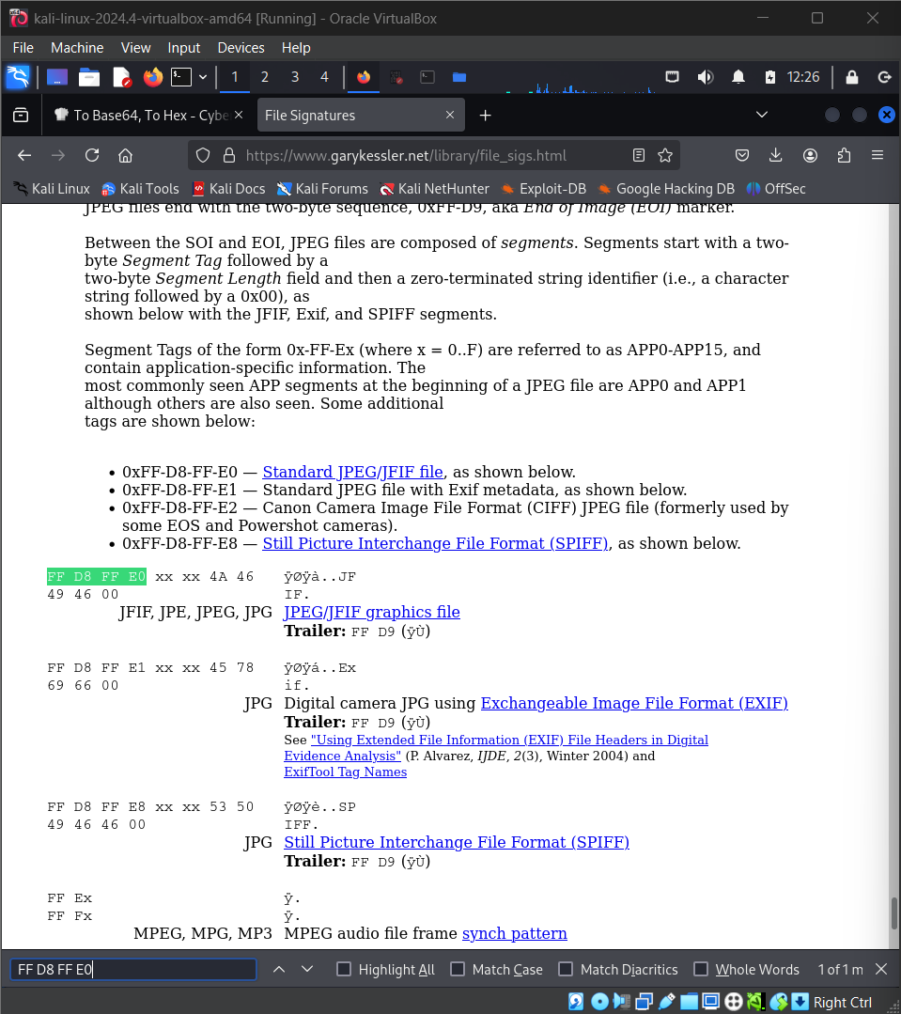
Hex Value-Match
- GoodJobMajor
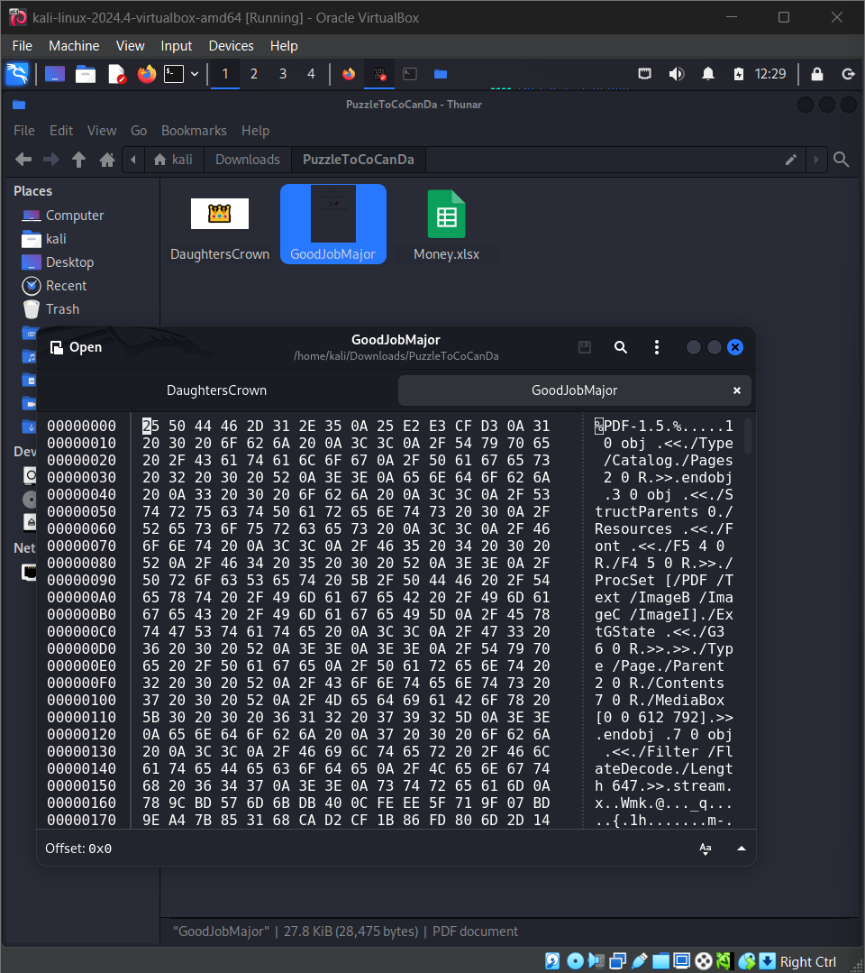
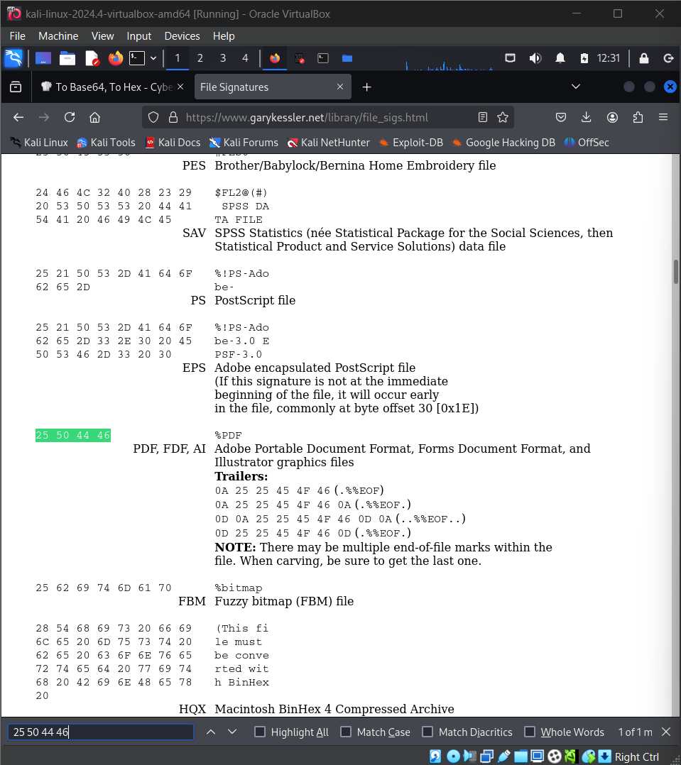
Hex Value-Match
- Money.xlsx
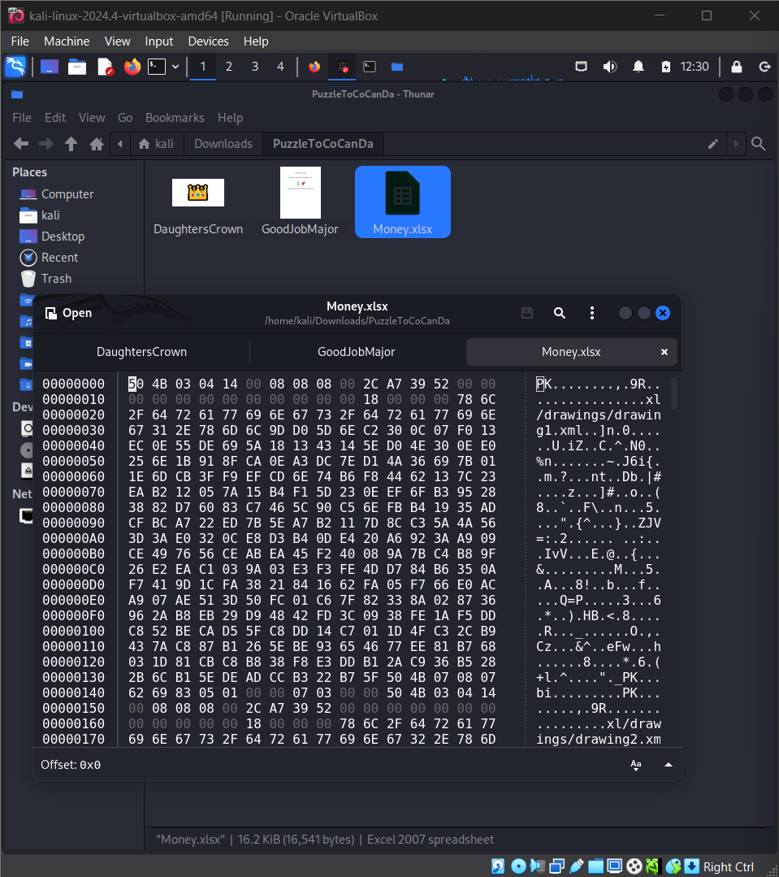
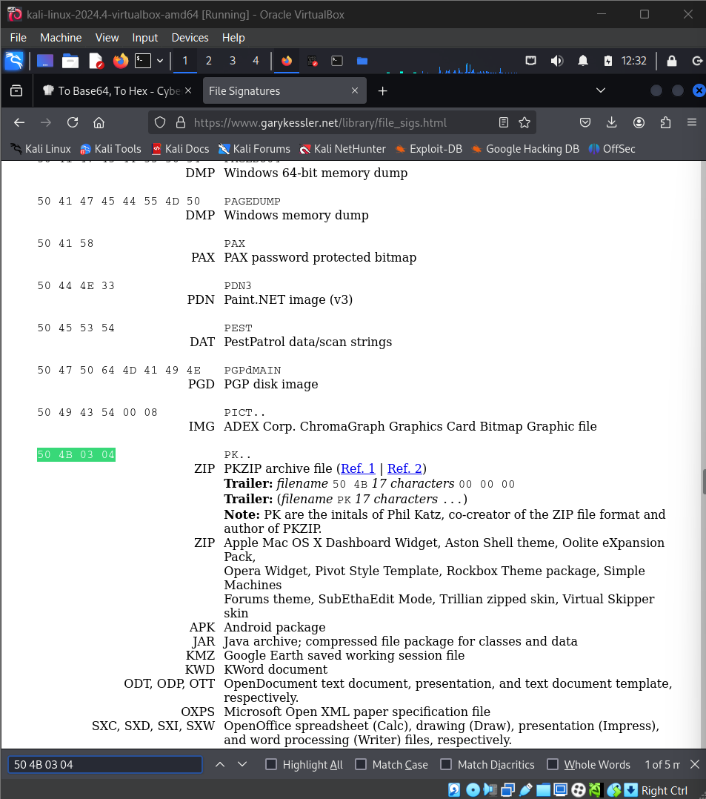
Hex Value- MisMatch
Opening the Spreadsheet in google spreadsheet using fake gmail

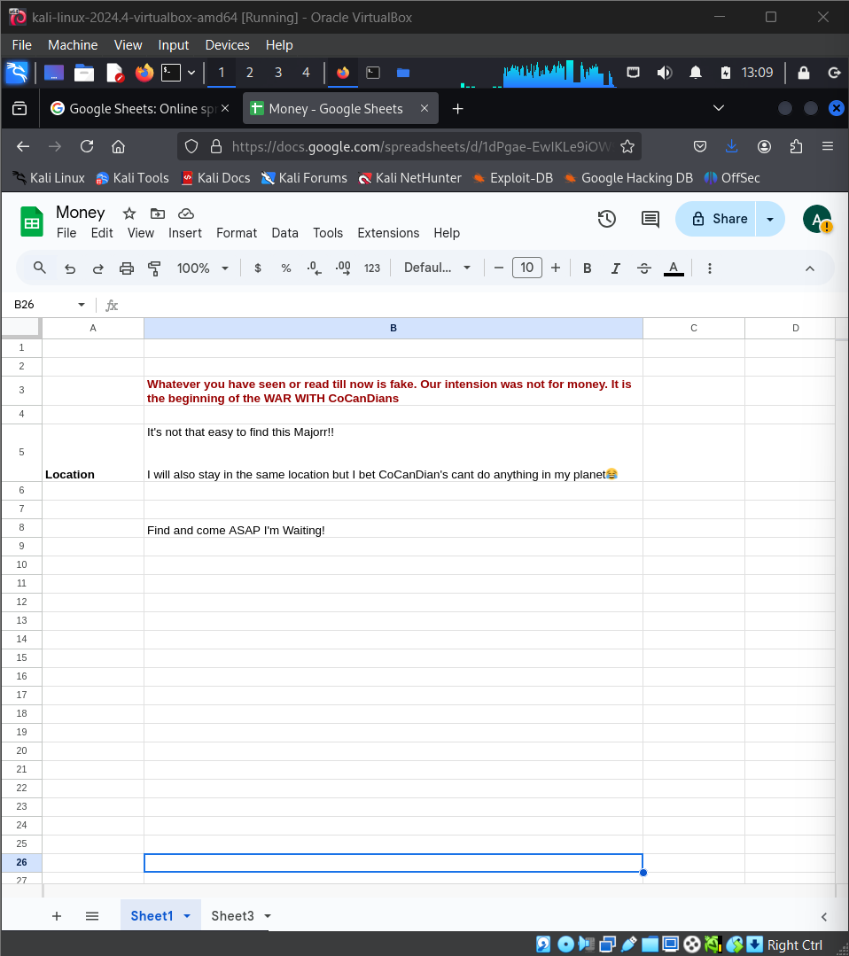

Hidden Message found in Sheert 3

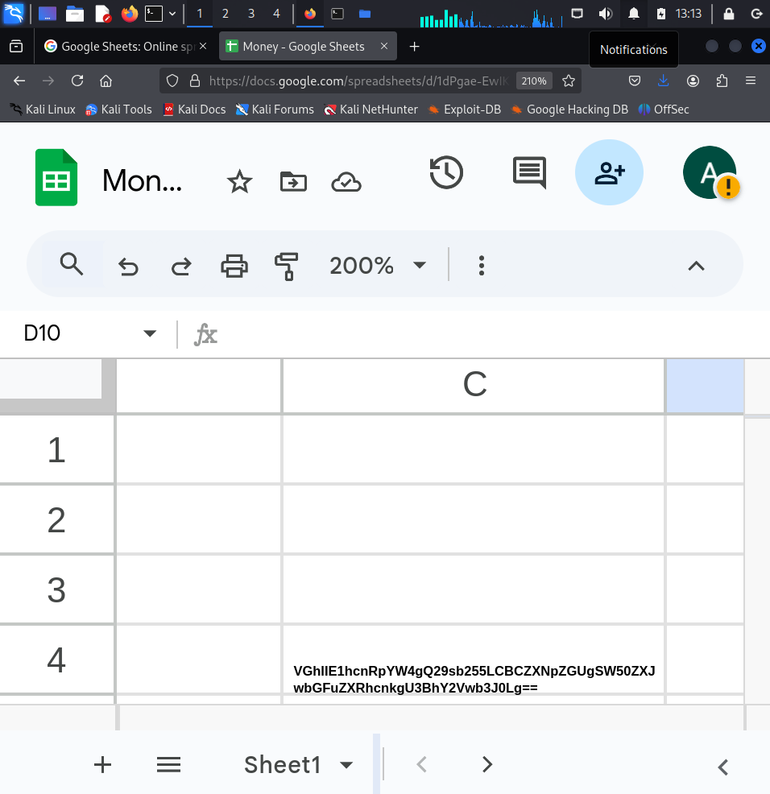

Decoding it from base 64 Using Cyberchef- Found The Location

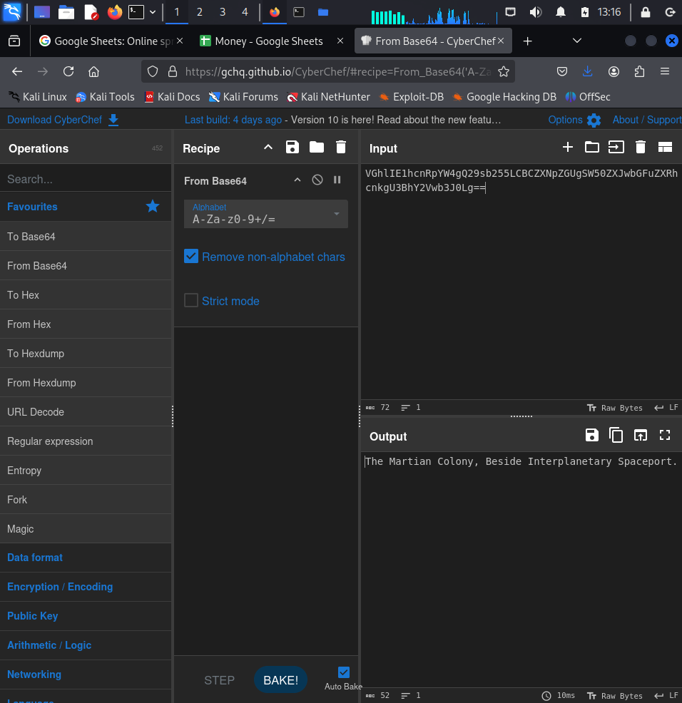

Further Checking

- traceout 93.99.104.210
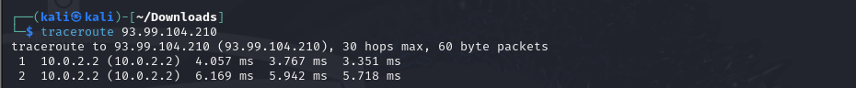

- nmap -sS 93.99.104.210
